Final Project for CSTS-UH 1078 Networks, Fall 2019

Voltaire’s Philosophical Dictionary Project

Submitted By:

Hamd Bin Fahad

Sashank Silwal

Yashaswi Malla

# Introduction

Francois-Marie Aironet was a French philosopher and a rationalist thinker. Voltaire was his pen name. He was born in 1694 in France. It was the time when Louis XIV was the king of France. Voltaire became one of the leading writers of The Enlightenment, which is a movement of intellectuals in the late 17th and 18th century, emphasizing reason, individualism, and skepticism. He criticized the role of the church, especially the Roman Catholic Church. He was a strong advocate of a liberal society where one can easily exercise his right to speak freely. He firmly believed that the church has nothing to do with the matters of state.

The situation of people in France took a toll on him. He blamed not only the French aristocracy who was ruling with an iron fist but also the role of the church. He wanted equality and fundamental rights for his people. This was the time when he started reading Enlightenment philosophers like Isaac Newton, John Locke and Francis Bacon. He got much impressed by them and later himself became an Enlightenment writer.

His keen observation about his society and his people led him to criticize all religions in general, like Christianity, Judaism, and Islam. However, he praised Hinduism because he was a vegetarian and an advocate of animal rights, and these two were the main traits of the Hindu religion. He regarded Hindus as “peaceful and innocent people, equally incapable of hurting others or defending themselves.”

In 1718 Oedipus was performed. This was an adaptation of Sophocles’ tragedy Oedipus, and this was Voltaire’s best-known play in his early days. He did a tremendous job in writing historical and philosophical works. The Henriade and The Maid of Orleans are among his most famous poems, which he could not complete.

Micromegas, Plato’s Dream, and Candide are considered as Voltaire’s great philosophical works. To know Voltaire’s concepts of Enlightenment, one will have to study Dictionnaire Philosophique. It is a dictionary as well as an encyclopedia where you will come across how Voltaire rejects the ideas of the Roman Catholic Church.

Voltaire’s life was full of his arrests and exiles. His work would always be considered as rebellious. He faced the anger of the French ruling class as well as the French Church. He still exposed the church in front of his people.

He was arrested several times and send to exile many times in his life. He spent the last very precious years of his experience in exile. When he finally returned, he was 83 years old, and he was treated like a hero, he died shortly after, in 1778.

The Dictionnaire Philosophique (Philosophical Dictionary) is a collection of essays published by Voltaire in 1764. The alphabetically arranged articles often criticize the Roman Catholic Church and other institutions. The first edition, released in June 1764, went by the name of Dictionnaire Philosophique Portatif. Later versions were expanded into two volumes consisting of 120 articles. Gabriel Grasset published the first editions anonymously in Geneva. Due to the volatile content of the dictionary, Voltaire chose Grasset over his usual publisher to ensure his anonymity. The Dictionnaire was a lifelong project for Voltaire. It represents the culmination of his views on Christianity, God, morality, and other subjects.

The purpose of Philosophical Dictionary was to act as a guide for individuals and society. It leads people to the reason of everything they observe in their lives. The completion of the Philosophical Dictionary was a significant milestone of the Enlightenment. Other than right, its emphasis was on freedom of speech, religion, how a religion should have nothing to do with the affairs of the state. Voltaire was so concerned about the church because the church was involved in every aspect of life. Church was enjoying a high power not only in France but also almost everywhere in Europe. Voltaire wanted to expose the church and its hypocrisy. Voltaire could see the long-term effects of the church on humanity. People were scared by the superstitious kind of punishments offered by the church as a result of their deeds. As a result of that, people will always look towards priests and other so-called people working for God for their solution. They would go to them and will try to offer them anything to get pardoned. Hence, people in church would always exploit them. Voltaire wanted people to be free of these chains of religious slavery. He wanted people not to be scared of them anymore and use their mind and wisdom in their daily lives. In his eyes, religion was far from being beneficial for the people. He saw men who backed “madness with murder” and men who killed “for love of God”, (202). This quotation shows his awareness about the church’s wickedness, “shall a reed, laid low in the mud by the wind, say to a fellow reed fallen in the opposite direction: “crawl! As I crawl, wretch, or I shall petition that you be torn up by the roots and burned.”

Voltaire’s Philosophical Dictionary is a unique piece of work in its domain. It is organized alphabetically, and it can still appeal to a reader. The way Voltaire defines the meaning or concept is fantastic. Sometimes he narrates a story to give the sense. Sometimes he becomes satirical to provide the purpose. Sometimes he takes an account from the Bible and adds his commentary to it.

For instance, when he explains the meaning of adultery, he tells us a story about a senior magistrate of a French Town that how he married a woman who was seduced by a priest before her marriage. Now magistrate thinks that by marrying such a lady, he punished himself, and now he wanted to remarry, but he does not want to give that right to his wife. Now Voltaire tries to explain the hypocrisy of the church that they allow a man to remarry, but they didn’t allow a woman to remarry. Furthermore, they blame a woman for adultery, not a man.

Voltaire’s exile in England for three years from 1726 to 1729 transformed him completely. English philosophy influenced him a lot, and he became a great philosopher. His stay in England helped him polish his capabilities he was not aware of. He was influenced not only by the British literary culture but also got influenced by their political class. He successfully learned the English language and was able to write it fluently. He met some great English men like Alexander Pope, Jonathan Swift, George Berkely, and Samuel Clarke. The liberalism of English institutions greatly influenced him, and he led to the conclusion that because of this, liberalism English society is producing great scientists like Sir Isaac Newton and philosophers like John Locke.

Later, when he returned to France, he tried to apply his knowledge and skills in France, which he learned in England. Although he faced many hardships in pursuing his dream of liberalizing French society, but he never gave up. Writing Philosophical Dictionary was never an easy task, but he took this challenge with all his heart and gave us a masterpiece of his writings. In his Philosophical Dictionary, he tried to explain everything philosophically and with logic and reasoning. He used some out of the box techniques for this purpose. For instance, sometimes, he tells us a story and a fable, and he wants us to reach a conclusion and get the actual meaning of the word.

Voltaire’s Enlightenment Philosophy is a set of intellectual sentences and orientations. In his Philosophical Dictionary, Voltaire tells about “advocate”, the one who studies the laws of Theodosius and Justinian for three years. Hence, he gets the right to plead causes for money.

Voltaire discusses about “Destiny” in his Philosophical Dictionary. He criticized the concept of destiny, which is given by the church. The church tells us that everything that happens in your life is prewritten. What would occur in the future if your life has already been written down by supreme forces? Your successes, your failures, marriages, divorces, traveling, and every single thing in your life are prewritten. Voltaire says that we first follow a pattern in our lives, which is well decided even before our births. Then we act according to that pattern, and then we get judged. Now, this is not fair because, according to church, we have to do whatever is written. Then how can we be held responsible for that deed which we were supposed to do in anyways? This idea of destiny given by church is beyond logic. It has nothing to do with reasoning. It is against conventional wisdom.

Next, in his philosophical Dictionary, the word “Devout” comes and this means devoted, but this word was associated with monks and nuns. Everything should be equally righteous. Monks or nuns have no right to consider themselves more worthy than a common man. If they are doing some religious rituals, it does not mean they are superior to those who don’t do those rituals.

While talking about “faith” in his Philosophical Dictionary, Voltaire says that faith makes people blind in their beliefs. If they have a hope in something, then they would consider it a divine thing. If they have faith in a priest, they will think of him doing some religious duties. Hence, people will always feel that they are some superhuman species, and they are very close to God, and that is why nothing can go wrong against them, and no one can harm them. In short, we can say that faith makes people blind. It does not tell them to look at things logically. Faith does not allow them to use reasoning. Principle requires them to follow someone blindly. Hope is against the essence of liberalism.

When Voltaire talks about “Equality” in his Philosophical Dictionary, his keen observation of the world helps him a lot. One has to appreciate his feelings towards the entire humanity. He argues that equality should mean that all men and women are equal, they were created equal by the creator, and they should be treated equally on this planet. But the matter of the fact is that men have always been treated superior to women. Which clearly shows that men and women are not equal entities. One aspect of this is dependence. Once someone is dependent on another, it means they are not equal. Some men on this planet are called “His Highness” or “His Holiness” and this is because the majority of people’s needs in a country are fulfilled by the men with these titles. In today’s world, there are so many classes that divide people. For instance, there are plentiful, and there are weak, and then among the poor, there are more gradations. In short, we can say that this might be an unfair distribution of wealth, which creates classes, and it takes humanity far from equality. Our systems, somewhat political, religious, or social, they are not proven good enough to eradicate this inequality among human beings. Religion also plays a negative role here. Faith tells people that whatever they have is according to their fate, and they don’t need to strive for more.

Talking about “Democracy” in his Philosophical Dictionary, Voltaire takes into account the different political systems the world has seen so far. Democracy is, so now, the best system for humanity. Freedom is the result of so many experiments. The religion has long ruled the world for a long time. Religious people had declared themselves as the representatives of the creator on this land. So they had the right to rule, but history tells us that humanity had to fight endless wars to gain control of territories. With time, dictatorship replaced religion or religious people. Dictatorship also proved fatal for the human being. Once again, there were wars over the lands and resources. The powerful will loot and plunder the resources of less privileged and weak nations. Moving with time, we reached a system called democracy. In today’s world, the majority of the countries have freedoms. Democracy has proved itself, so far, the best system on this land. Democracy is the government of the people, by the people and for the people. Freedom provides opportunities for its people to prosper. It focuses on the people of the land.

# Findings

The first step in this project was to modify Voltaire’s Philosophical Dictionary and divide it into 99 sub parts based on the lexical terms it contained. The division into sub parts was accomplished by using special character to separate one section from the other. From that we derived a Python dictionary constituting of lexical terms as the keys and their corresponding sub texts as the values. The next step was to look for references to other lexical term in each of the sub texts.

If a reference to any other lexical term was found in the sub text, we formed a directed edge with the title/term of the sub text pointing to the referenced lexical term. In this way we formed the graph of lexical terms and references in Voltaire’s Philosophical Dictionary. From this graph, we then derived the largest strongly connected component.

Shown below is the directed graph of lexical items and references in Voltaire’s Philosophical Dictionary.

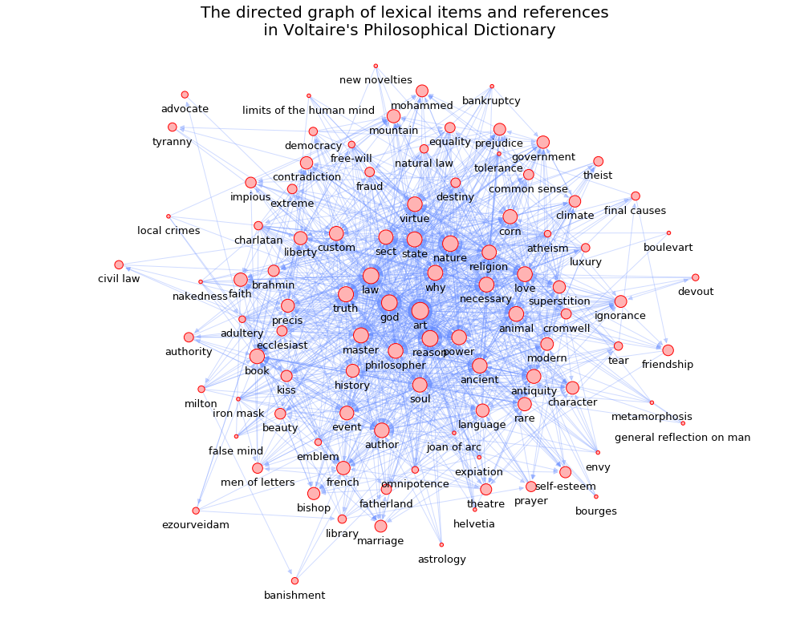

* Voltaire's Philosophical Dictionary graph has 99 nodes and 1136 edges.
* It is a directed, simple graph.
* The graph is not strongly connected and has 21 strongly connected components.
* Voltaire's Philosophical Dictionary graph is a weakly connected graph and hence, has no isolates.
* The density, transitivity and reciprocity of Voltaire's Philosophical Dictionary graph are 0.117, 0.322 and 0.146 respectively.

Similarly, the largest strongly connected component of the graph of lexical items and references in Voltaire’s Philosophical Dictionary is shown below:

# 

The diameter of the largest strongly connected component of Voltaire's Philosophical Dictionary graph is 5.

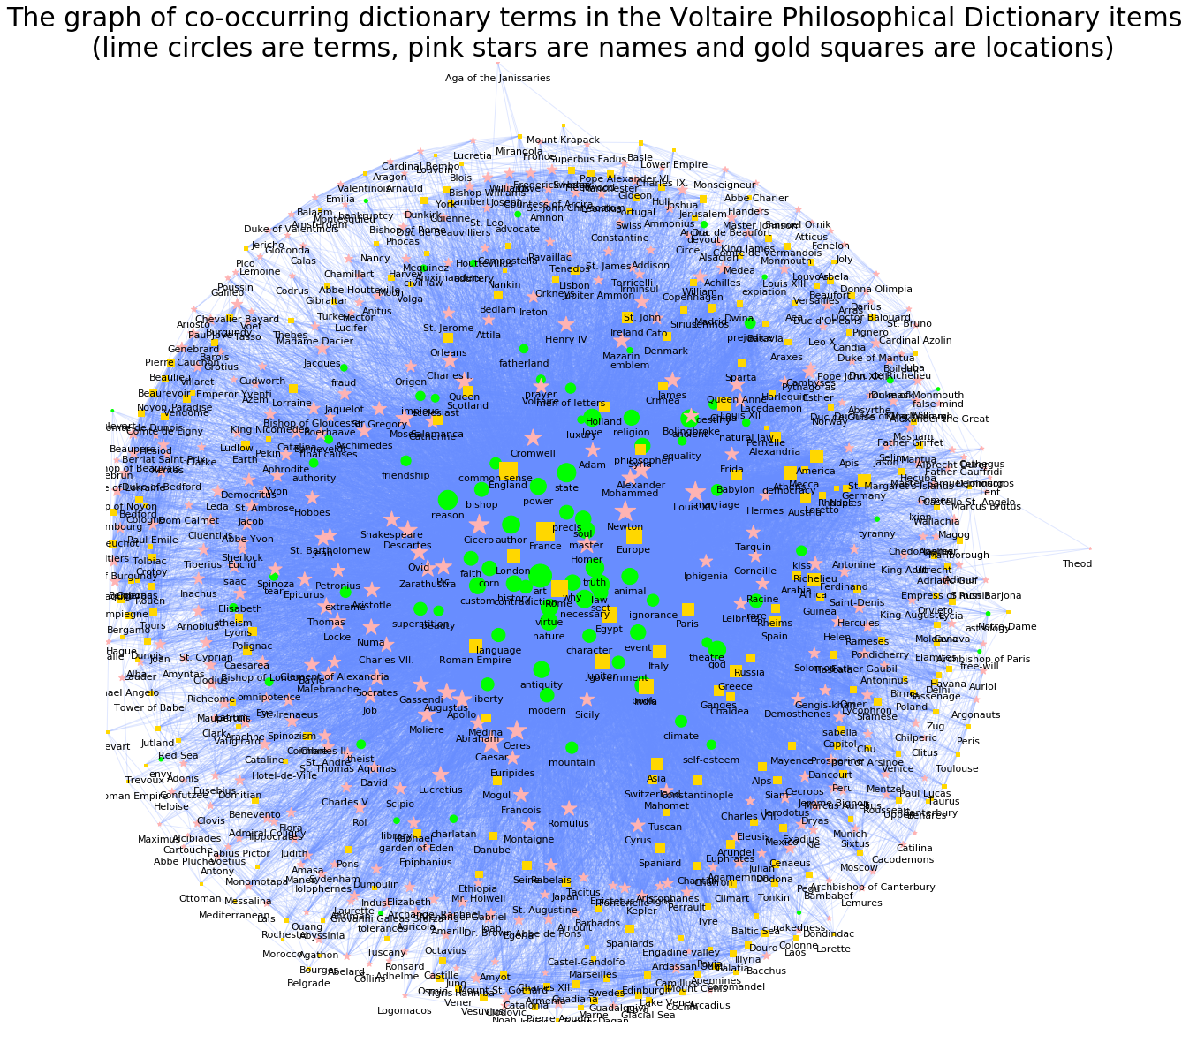

# 

# 

# 

# 

# 

# 

# 

# 

# 

# 

# 

# 

# 

# 

# 

# 

# 

# 

# Works Cited

Editors, Biography.com. “Voltaire Biography.” The Biography.com Website, A&amp;E Television Networks, 2 Apr. 2014, Www.biography.com/scholar/voltaire.

Jane, M. Birkenstock. “Voltaire”. Voltaire, Chateau De Cirey, 2001, www.visitvoltaire.com/voltaire_bio.htm.

Morley, John. “Voltaire, The Works of Voltaire.” Online Library of Liberty, 2004, www.oll.libertyfund.org/.

Pomeau, Rene Henry. “Explore Encyclopedia Britannica.” Encyclopædia Britannica, Encyclopædia Britannica, Inc., 20 July 1998, www.britannica.com/.

Writework, Contributors. “Summary of Voltaire’s Philosophical Dictionary.” WriteWork, 30 Aug. 2004, www.writework.com/.